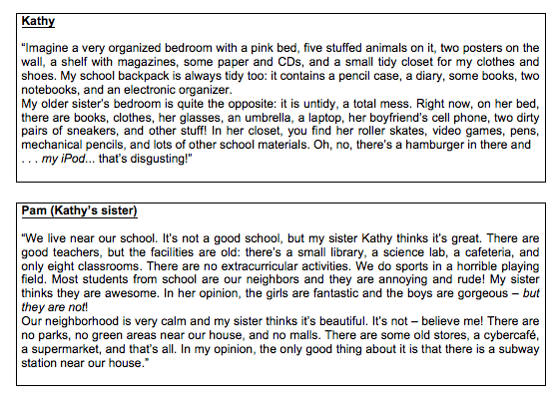

1) Underline and correct the wrong information. (0,5)
a) Pam’s roller skates are in her backpack.
b) Kathy thinks the students in her school are boring.
c) There are old malls in their neighborhood.
d) There is a hospital near the girls’ house.
e) In Pam’s point of view, the facilities are new.

2) Answer the questions. (0,5)
a) Where are Pam’s glasses?
____________________________________________________________
b) How many science labs are there in their school?
There ____________________________________________________________

3) Complete the sentences with one word from Kathy’s text. (0,5)
a) Kathy’s bedroom is really ____________________.
b) There are posters on her bedroom ____________________.
c) Her books are in her ____________________.
d) Pam’s roller skates are in the ____________________.
e) Kathy’s ____________________is inside Pam’s closet.

4) Answer the questions using the cues given.

a) Were your brothers playing basketball at the club? (no / soccer)
_________________________________________________________________
b) Was Camilla eating a salad in the restaurant? (no / pasta)
_________________________________________________________________
c) Was your teacher correcting the Math exercises? (no / Portuguese)
_________________________________________________________________
d) Were your parents working at the bank? (no / office)
_________________________________________________________________
e) Was the cat sleeping in the garden? (no / kitchen)
_________________________________________________________________

5) Complete the sentences with the correct form of the verbs in parentheses, in the past continuous:
a) Margaret _________________ (cross) the street when she fell.
b) I _________________ (have dinner) when Susan knocked on the door.
c) While the Clintons _______________ (drive) to Los Angeles, their neighbors _________________ (fly) to Canada.
d) We __________________ (cook) when we ran out of salt.
- While the actress _________________ (act), the director ___________________ (sleep).

6) Fill in the blanks with the correct words from the box.
happy sad relieved tired terrified angry

a) I was so _______________________ when my boyfriend arrived. It was late and dark and I was becoming _______________________.
b) When I told my mom about my bad grade in Physics, she got very _______________________ at me.
c) How come you don’t get _______________________ after running four kilometers?
d) My sister is very _______________________. She passed her driving test today.
e) When I first moved to that neighborhood, I was _______________________ because I had no friends.

7) Use the comparative of the adjectives:

- Sharks are _________________ Lions. (dangerous)

- He is ________________ he used to be last year. (fat)

- Your poem is _________________ beautiful than mine. (beautiful)

- George runs ________________ Jim. (fast)

Text: Gaza-Israel conflict: What can Israel and Hamas gain?
By Kevin Connolly BBC News, Jerusalem http://www.bbc.com/news/world-middle-east-28263042 (accessed on 7/12/2014)
It took seven days for the war that no-one seemed to want to become the war that no-one seems to know how to stop. The Israeli public had mourned three teenagers kidnapped and murdered as they hitchhiked home from school across the West Bank and Palestinians had grieved for a boy abducted and killed in a grisly act of reprisal as he waited for early prayers at a local mosque. There was rioting in Arab East Jerusalem and some of the towns of northern Israel with Palestinian populations but it subsided relatively quickly and the rocket fire from Gaza was a background rumble - nothing that Israel’s sophisticated Iron Dome anti-missile system couldn’t handle. There were even hints that a truce might be possible with both Israel and Hamas using the cautious but optimistic formula that calm from the other side would be met with calm. Within hours, though, it seemed hostilities began to intensify - and a week later Israeli military sources say they’ve hit more than a thousand targets in Gaza and that militant groups there have fired more than 500 rockets at Israel. More importantly, the death toll in Gaza has risen to 100 with more than 600 people injured including many civilians.

De acordo com o texto:
8) a. Ninguém sabe por que o conflito começou.
b. Ninguém sabe como acabar com o conflito.
c. Ambos os lados querem desenvolver o conflito.
d. O conflito teve início em base política.

9) a. A população israelense estava chateada pelo sequestro de três adolescentes e de um adolescente em uma mesquita.
b. Os adolescentes israelenses foram sequestrados por represália à morte de um adolescente palestino.
c. A população israelense estava enlutada por três adolescentes mortos ao voltarem para casa e a palestina por um adolescente que esperava pelas orações em uma mesquita.
d. Todos os adolescentes foram sequestrados.

10) a. A trégua é possível e está próxima.
b. A fórmula para a trégua é usar a calma.
c. A trégua não adiantou e o ambiente hostil se intensificou.
d. Não é possível conseguir trégua. Photocopiable – Student’s copy

11) a. A taxa de mortalidade aumenta paulatinamente.
b. A Taxa de mortalidade apresentada não inclui civis.
c. A taxa de mortalidade apresentada só inclui civis.
d. A taxa de mortalidade inclui civis e grupos militante

12) Change the sentences into the negative and interrogative forms:

- Kevin drove to Boston last night.

Neg: _____________________________________

Int: ______________________________________

- Michael and Susan traveled to England last year.
Neg: ________________________________________

Int: _________________________________________

