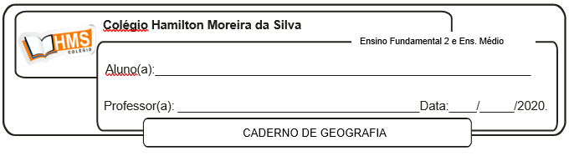

1. Explique com suas palavras por que os Estados Unidos são um país com dimensões contientais e com subsolo privilegiado.

________________________________________________________________________________________________________________________________________________________________________________________________________________________________________________________________________________________________________________________________________________

2. Barack Obama foi presidente dos Estados Unidos entre 2009 e 2017, ano em que foi substituído pelo novo presidente eleito Donald Trump. Leia a notícia abaixo e depois responda às questões.

**Trump assina decreto que revoga medidas ambientais de Obama**

O presidente dos Estados Unidos, Donald Trump, assinou hoje (28) o decreto-executivo da Independência Energética, que revê medidas do governo do ex-presidente Barack Obama que tinham como objetivo diminuir as emissões de gases de efeito estufa dos Estados Unidos para atender aos compromissos feitos no Acordo de Paris, de 2015. Segundo Trump, o decreto é necessário uma vez que a gestão Obama implementou regulamentações “caras que prejudicaram os empregos e a produção de energia nos Estados Unidos”. “Nós vamos colocar um fim à guerra contra o carvão”, disse o presidente norte-americano.

Em seu discurso, Trump fez referência ao Plano de Energia Limpa de Obama, que obrigou os estados a limitarem as emissões de carbono em suas usinas energéticas. Segundo a Casa Branca, o plano poderia custar aos americanos até U$ 39 bilhões por ano e aumentar em pelo menos 10% o preço da eletricidade em muitos estados.[...]

<https://agenciabrasil.ebc.com.br/internacional/noticia/2017-03/trump-assina-decreto-qu-revoga-medidas-ambientais-de-obama>

a) De acordo com a notícia, por que o governo de Barack Obama tinha implantado o chamado Plano de Energia Limpa?

________________________________________________________________________________________________________________________________________________________________________________________________________________________________________________________________________________________________________________________________________________

b) Que decisão o presidente Trump tomou em relação ao Plano de Energia Limpa?

________________________________________________________________________________________________________________________________________________________________________________________________________________________________________________________________________________________________________________________________________________

c) O que Trump quis dizer com “colocar um fim à guerra contra o carvão”?

________________________________________________________________________________________________________________________________________________________________________________________________________________________________________________________________________________________________________________________________________________

d) De acordo com seus cochecimentos, quais são as possíveis consequências dessa decisão do presidente estadunidense?

________________________________________________________________________________________________________________________________________________________________________________________________________________________________________________________________________________________________________________________________________________

3. Sobre o gás xisto nos Estados Unidos, responda.

a) O que é o xisto?

________________________________________________________________________________________________________________________________________________________________________________________________________________________________________________________________________________________________________________________________________________

b) Quando começou a ser explorado no país?

________________________________________________________________________________________________________________________________________________________________________________________________________________________________________________________________________________________________________________________________________________

c) Quais as consequências para a economia estadunidense?

________________________________________________________________________________________________________________________________________________________________________________________________________________________________________________________________________________________________________________________________________________

4. Interprete o mapa abaixo e responda às questões a seguir.

**Estados Unidos: organização do espaço industrial**

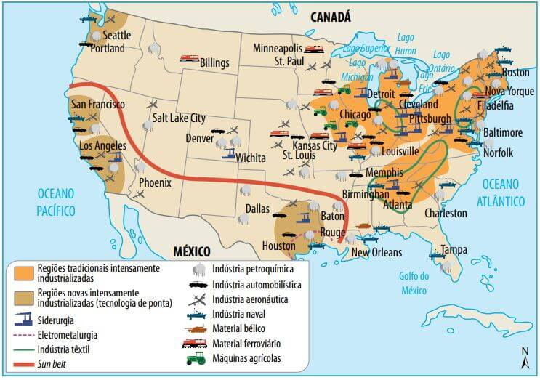

a) Localize no mapa o Vele do Silício. Quais são os tipos de indústria que predominam nesse polo industrial?

____________________________________________________________________________________________________________________________________________________________________________________________________________________________________________________________

b) Localize no mapa o manufacturing Belt e explique o que caracteriza essa região industrial dos Estados Unidos.

________________________________________________________________________________________________________________________________________________________________________________________________________________________________________________________________________________________________________________________________________________