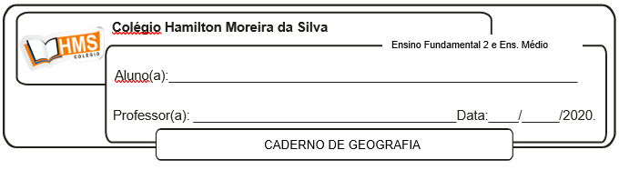

**Exercícios**

1. Faça um pequeno Comentário sobre a relação econômica entre Estados Unidos e China.

____________________________________________________________________________________________________________________________________________________________________________________________________________________________________________________________________________________________________________________________________________________________________________________________________________________________________

2. Caracterize a economia dos Estados Unidos.

________________________________________________________________________________________________________________________________________________________________________________________________________________________________________________________________________________________________________________________________________________

3. Como os Estados Unidos exercem influência em grande parte dos países do mundo atual?

________________________________________________________________________________________________________________________________________________________________________________________________________________________________________________________________________________________________________________________________________________