1. Observe a imagem e responda:

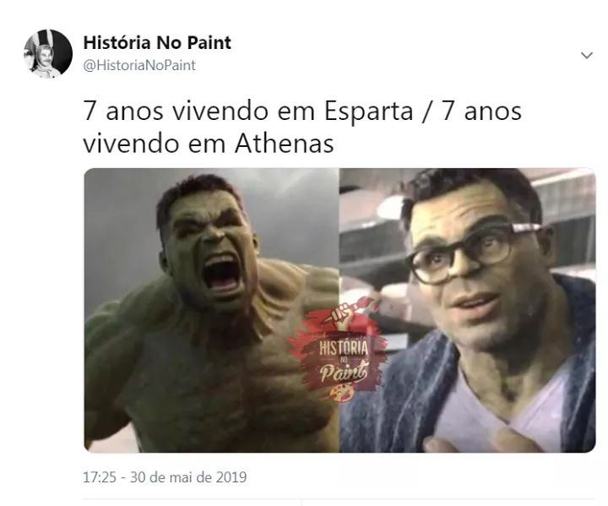

De acordo com o que foi estudado sobre as cidades-Estado Atenas e Esparta, explique a imagem acima.

_________________________________________________________________________________________________________________________________________________________________________________________________________________________________________________________________________________________________________________________________________________________________________________________________

1. Faça uma pesquisa e explique os significados das seguintes palavras/conceitos:
2. República
3. Democracia
4. Cidade-Estado
5. Oligarquia
6. Civilização
7. Politeísta
8. Laconismo
9. Sufrágio universal
10. Caracterize:
11. Democracia representativa

_________________________________________________________________________________________________________________________________________________________________________________________________________________________________________________________________________________________________________________

1. Democracia direta

_______________________________________________________________________________________________________________________________________________________________________________________________________________________________________