

**Colégio Hamilton Moreira da Silva**

Aluno(a):_______________________________________________________ ________________________________________________________________

Professor(a):______Giselle_________________________ Data:____/_____/2020. ______/__________/_______

6°ano do Ensino Fundamental II



Matemática II

* **Gabarito dos exercícios do livro de Matemática; pág.: 69.**

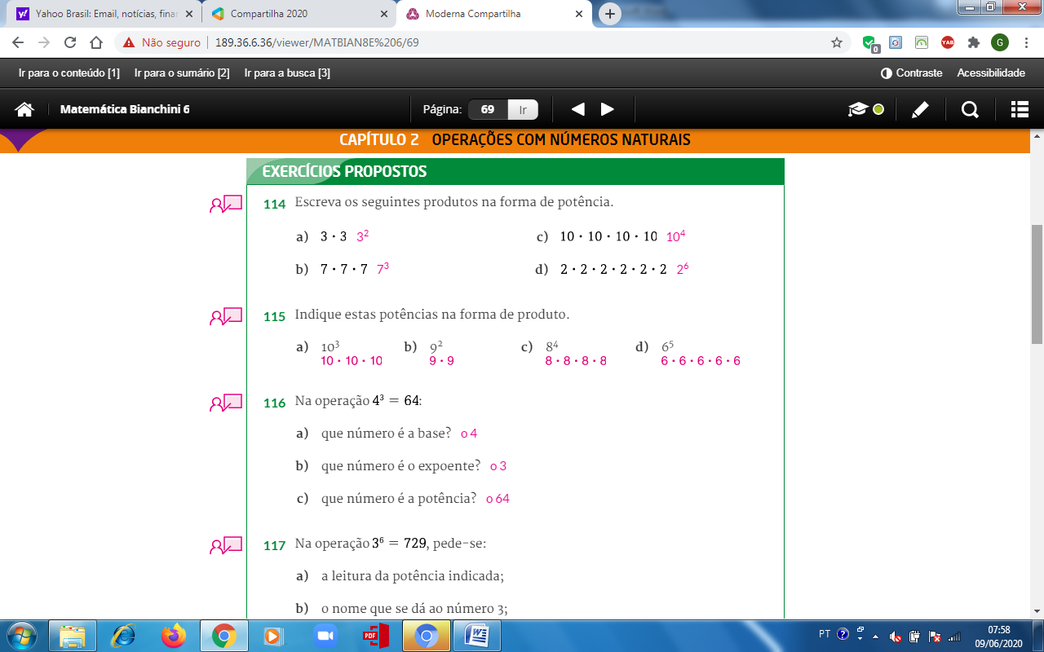

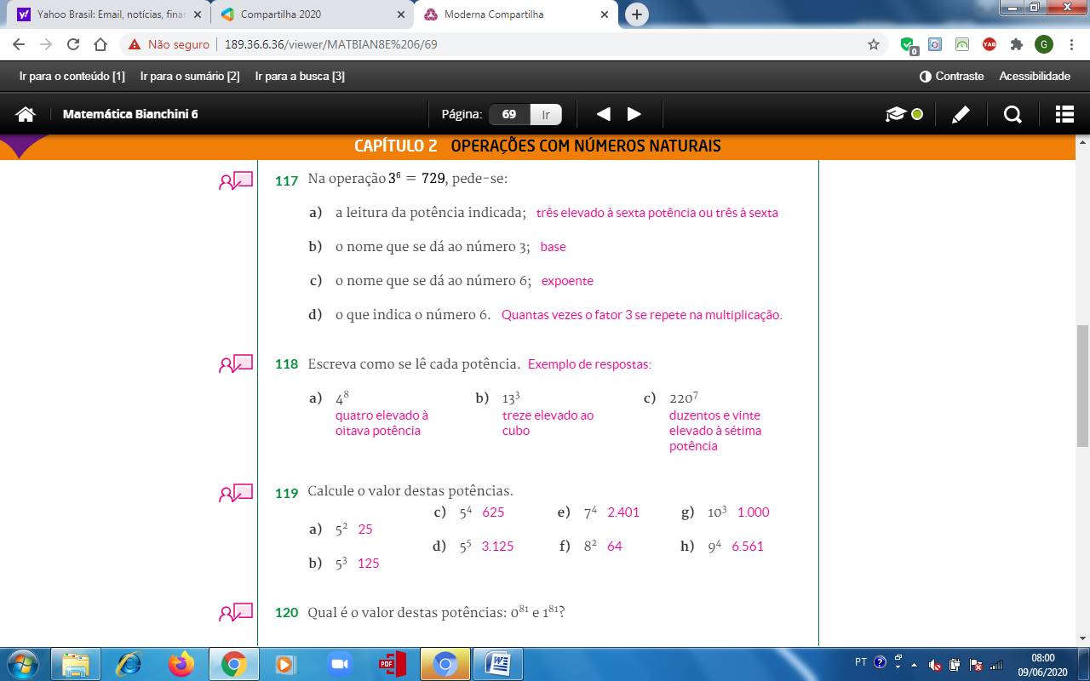

a) 5 . 5 = 25 c) 5 . 5 . 5 . 5 = 625 e) 7 . 7 . 7 . 7 = 2.401 g) 10 . 10 . 10 = 1000

b) 5 . 5 . 5 = 125 d) 5 . 5 . 5 . 5 . 5 = 3.125 f) 8 . 8 = 64 e) 9 . 9 . 9 . 9 = 81

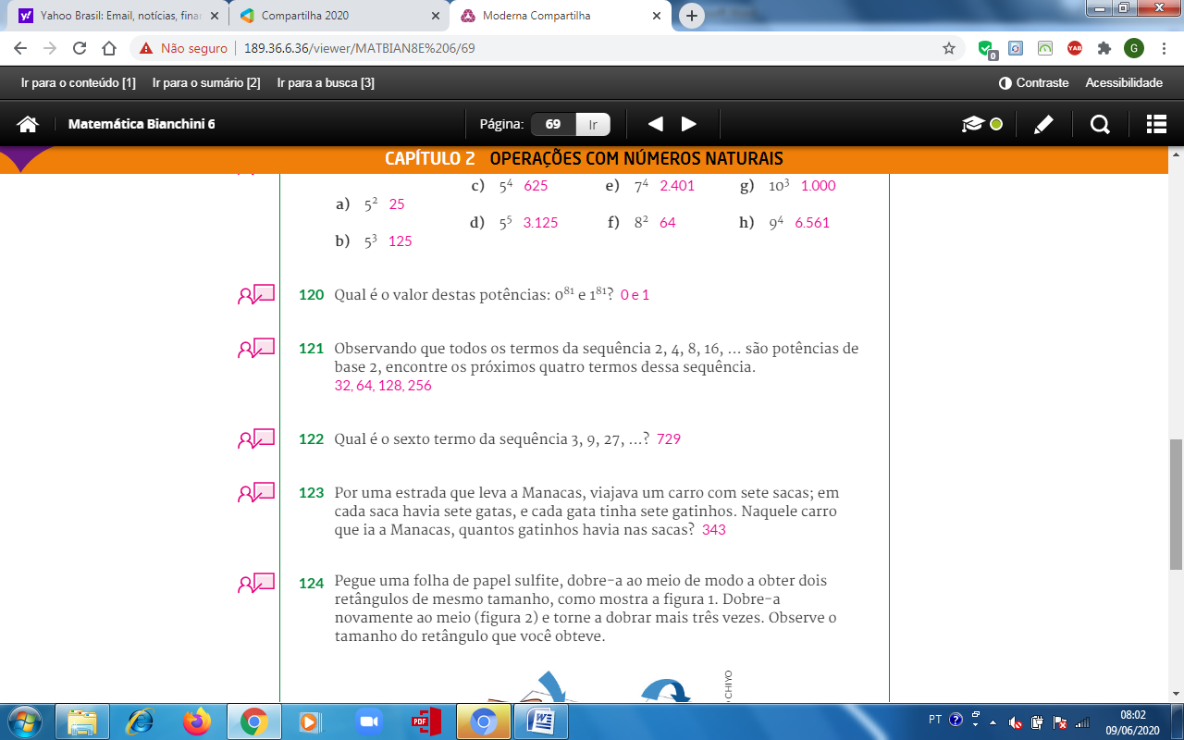

7.7.7 = $7^{3}$ = 343 gatinhos

$2^{1}$ = 2 / $2^{2}$ = 2.2 = 4 / $2^{3}$ = 2.2.2 =8 / $2^{4}$ = 2.2.2.2 = 16

$2^{5}$ = 32 / $2^{6}$ = 64 / $2^{7}$ = 128 / $2^{8}$ = 256

/

**3, 9, 27, 81, 243, 729**

27 + 27 + 27 = 81

81 + 81 + 81 = 243

243 + 243 + 243 = 729

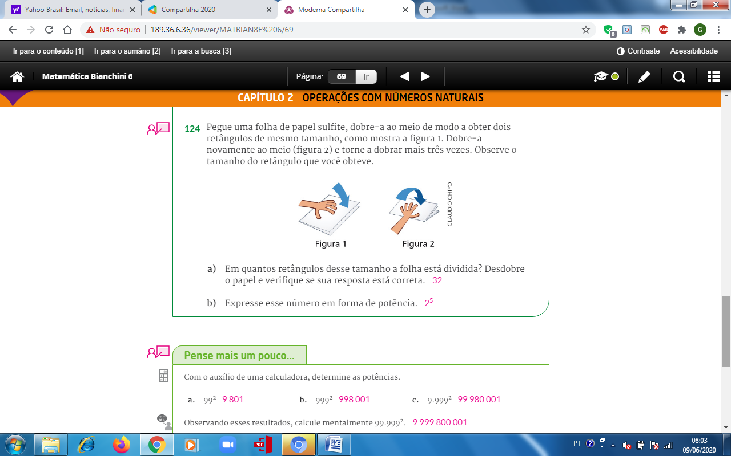

$2^{5}$ =2.2.2.2.2 = 32

