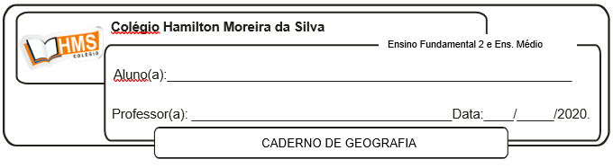

**Enviar os exercícios prontos para o e-mail:** [**vandersonalmeida.geo@hotmail.com**](mailto:vandersonalmeida.geo@hotmail.com)

**Exercícios**

1. Quais estados compõem a região Nordeste?

____________________________________________________________________________________________________________________________________________________________________________________________________________________________________________________________

2. Quais são as principais atividades econômicas da região Nordeste?

____________________________________________________________________________________________________________________________________________________________________________________________________________________________________________________________

3. Sobre o clima da sub-região nordestina Zona da Mata, responda:

a) Qual é o nome deste clima?

____________________________________________________________________________________

b) Quais fatores influenciam no aparecimento das frequentes chuvas de outono e inverno nesta região?

____________________________________________________________________________________

4. Explique como o planalto da Borborema influencia no clima da região nordeste.

____________________________________________________________________________________________________________________________________________________________________________________________________________________________________________________________

5. Na região sul da Bahia temos o aparecimento de um fértil solo, o massapé. Quais são os principais produtos cultivados nesta região?

________________________________________________________________________________________________________________________________________________________________________

6. Por que o Rio São Francisco é considerado de grande importância para a região nordeste?

____________________________________________________________________________________________________________________________________________________________________________________________________________________________________________________________

7. Explique o que você entendeu por “indústria da seca”.

____________________________________________________________________________________________________________________________________________________________________________________________________________________________________________________________