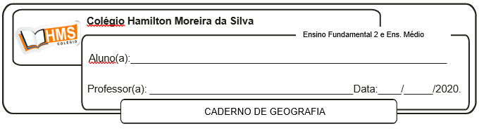

**Enviar os exercícios prontos para o e-mail:** [**vandersonalmeida.geo@hotmail.com**](mailto:vandersonalmeida.geo@hotmail.com)

**Exercícios**

1. Com a morte de Mao Tsé Tung, uma série de reformas econômicas foi iniciada na China. Explique as mudanças que ocorreram no modelo econômico chinês a partir da década de 1980.

_________________________________________________________________________________________________________________________________________________________________________________________________________________________________________________________________________________________________________________________________________________________________________________________________________________________________________

2. Qual é a importância das ZEEs para o dinamismo da economia chinesa?

_________________________________________________________________________________________________________________________________________________________________________________________________________________________________________________________________________________________________________________________________________________________________________________________________________________________________________

3. Faça um pequeno comentário diferenciando a China Oriental da China Ocidental.

_________________________________________________________________________________________________________________________________________________________________________________________________________________________________________________________________________________________________________________________________________________________________________________________________________________________________________

4. Nestes tempos de globalização econômica, a China chama a atenção do mundo em função do seu imenso mercado consumidor e de um sistema político-econômico peculiar, denominado por alguns estudiosos "socialismo de mercado".

Apresente duas razões que justifiquem a utilização do termo "socialismo de mercado" para definir a situação chinesa.

_________________________________________________________________________________________________________________________________________________________________________________________________________________________________________________________________________________________________________________________________________________________________________________________________________________________________________

5. Quais reformas foram adotadas pela China com Deng Xiaoping no poder?

_________________________________________________________________________________________________________________________________________________________________________________________________________________________________________________________________________________________________________________________________________________________________________________________________________________________________________

6. Complete o quadro corretamente:

|  |  |
| --- | --- |
| **ZEEs** | |
| O que são e a porção do território chinês que se concentram |  |
| Objetivos do governo chinês ao criá-las |  |
| Vantagens para as empresas estrangeiras |  |

7. Faça um pequeno comentário sobre a indústria chinesa nos dias de hoje.

_________________________________________________________________________________________________________________________________________________________________________________________________________________________________________________________________________________________________________________________________________________________________________________________________________________________________________

8. Explique a seguinte afirmação: “A China é um grande importador de alimentos”.

_________________________________________________________________________________________________________________________________________________________________________________________________________________________________________________________________________________________________________________________________________________________________________________________________________________________________________

9. Que relações existem entre a distribuição populacional e a produção econômica na China?

_________________________________________________________________________________________________________________________________________________________________________________________________________________________________________________________________________________________________________________________________________________________________________________________________________________________________________

10. Quais foram os principais motivos do rápido crescimento da China nas últimas décadas?

_________________________________________________________________________________________________________________________________________________________________________________________________________________________________________________________________________________________________________________________________________________________________________________________________________________________________________