

**Colégio Hamilton Moreira da Silva**

Aluno(a):_______________________________________________________ ________________________________________________________________

Professor(a):_______________________________________ Data:___/___/2020. f).____/__________/_______

6°ano do Ensino Fundamental II



MATEMÁTICA I

* Gabarito dos exercícios do livro de Matemática, pág.: 96.

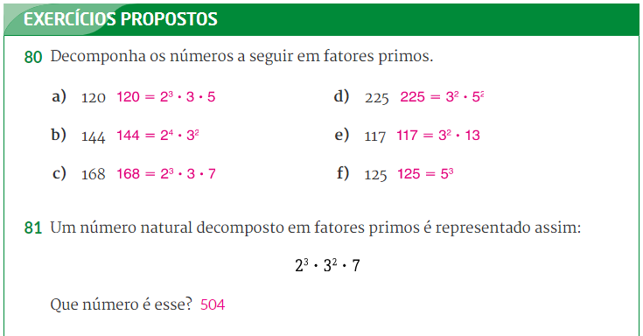

80) a ) 120 2 b) 144 2

60 2 72 2

30 2 36 2

15 3 18 2

5 5 9 3

1 2³.3.5 = 120 3 3

1. $2^{4}$. 3² = 144

c) 168 2 d) 225 3

84 2 75 3

42 2 25 5

21 3 5 5

7 7 1 3³.5³ = 225

1. 2³.3.7 = 168

e) 117 3 f) 125 5

39 3 25 5

13 13 5 5

1 3².13 = 117 1 5³ = 125

81) 2³ . 3² . 7 =

8 . 9. 7 =

72 . 7 =

504

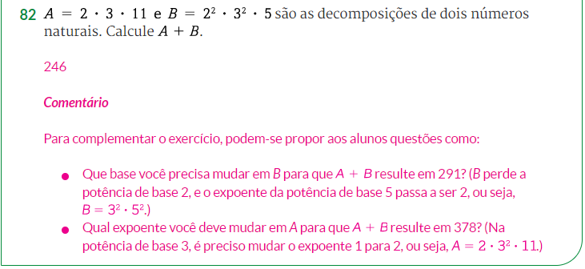

A = 2 . 3 . 11 B = 2² . 3² . 5 A + B = 66 + 180 = 246

A = 6 . 11 B = 4 . 9 . 5

A = 66 B = 36 . 5

B = 180