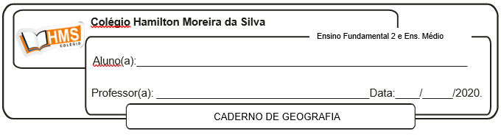

Exercícios

1. (Ufes 2012) Terremoto no Japão:

Data da ocorrência: 10 de março de 2011

Magnitude: 8,9 graus na escala Richter

Número de mortos: 13 mil

IDH*: 0,884 (muito elevado)

Terremoto no Haiti:

Data da ocorrência: 12 de janeiro de 2010

Magnitude: 7 graus na escala Richter

Número de mortos: 200 mil

IDH*: 0,404 (baixo)

*O IDH – Índice de Desenvolvimento Humano é formado por dados sobre esperança de vida ao nascer, escolaridade e distribuição da riqueza produzida. Varia de 0 a 1.

Explique

a) a semelhança na causa da ocorrência de terremotos, nos dois países;

____________________________________________________________________________________________________________________________________________________________________________________________________________________________________________________________________________________________________________________________________________________________________________________________________________________________________

b) a diferença no impacto social em consequência dos terremotos, entre os dois países, considerando suas situações socioeconômicas.

____________________________________________________________________________________________________________________________________________________________________________________________________________________________________________________________________________________________________________________________________________________________________________________________________________________________________

2. (Unifesp 2011) Observe a imagem, leia o texto e responda.



De acordo com a teoria das placas tectônicas, a crosta terrestre está dividida em placas de espessura média de 150 km, que flutuam sobre o substrato pastoso, a astenosfera.

(Almeida e Rigolin, 2005. Adaptado.)

a) Qual a relação existente entre a teoria da deriva dos continentes e a teoria das placas tectônicas?

____________________________________________________________________________________________________________________________________________________________________________________________________________________________________________________________________________________________________________________________________________________________________________________________________________________________________

b) Quais são os três tipos de limites entre as placas tectônicas?

____________________________________________________________________________________________________________________________________________________________________________________________________________________________________________________________________________________________________________________________________________________________________________________________________________________________________

c) Exemplifique 1 (um) tipo de relevo gerado no limite entre as placas tectônicas Sul-Americana e de Nazca.

____________________________________________________________________________________________________________________________________________________________________________________________________________________________________________________________________________________________________________________________________________________________________________________________________________________________________

4. Por que é reduzida a ocorrência de abalos sísmicos no Brasil?

____________________________________________________________________________________________________________________________________________________________________________________________________________________________________________________________________________________________________________________________________________________________________________________________________________________________________

Pág. 298 (nº 1 ao 3)

Pág. 302 (nº 1 ao 3)

Pág. 305 (nº 5)

Pág. 304 (nº 6 e 7)