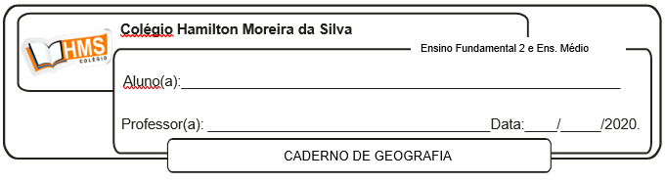

**Exercícios**

1. Faça uma relação entre a dependência do Japão em relação às matérias-primas e seu quadro natural.

____________________________________________________________________________________________________________________________________________________________________________________________________________________________________________________________________________________________________________________________________________________

2. O relevo japonês dificulta a instalação de novas indústrias. Como o Japão enfrenta essa limitação territorial?  
____________________________________________________________________________________________________________________________________________________________________________________________________________________________________________________________________________________________________________________________________________________

3. Explique os fatores responsáveis pela atual dinâmica demográfica japonesa, e quais as consequências futuras para a sociedade japonesa.

____________________________________________________________________________________________________________________________________________________________________________________________________________________________________________________________________________________________________________________________________________________

4. Até a alguns anos atrás a economia japonesa era a segunda maior do mundo. Será que isso continua assim?

____________________________________________________________________________________________________________________________________________________________________________________________________________________________________________________________________________________________________________________________________________________

5. Comente sobre a configuração e principais aspectos do território geográfico japonês .

____________________________________________________________________________________________________________________________________________________________________________________________________________________________________________________________________________________________________________________________________________________

6. Sobre a taxa natalidade no Japão: é alta, média ou baixa?  Por quê?

____________________________________________________________________________________________________________________________________________________________________________________________________________________________________________________________________________________________________________________________________________________

7. Justifique a frase: “A água é um recurso natural valioso para o Oriente Médio.”

____________________________________________________________________________________________________________________________________________________________________________________________________________________________________________________________________________________________________________________________________________________

8 . Por que a falta de água pode gerar conflitos no Oriente Médio?

____________________________________________________________________________________________________________________________________________________________________________________________________________________________________________________________________________________________________________________________________________________

9. Explique a frase: “O petróleo é uma riqueza contraditória para alguns países do Oriente Médio.”

____________________________________________________________________________________________________________________________________________________________________________________________________________________________________________________________________________________________________________________________________________________

10. Apresente duas razões para que o Oriente Médio seja considerado uma região estratégica.

____________________________________________________________________________________________________________________________________________________________________________________________________________________________________________________________________________________________________________________________________________________

11. Por que o Oriente Médio é conhecido como “barril de pólvora”?

____________________________________________________________________________________________________________________________________________________________________________________________________________________________________________________________________________________________________________________________________________________