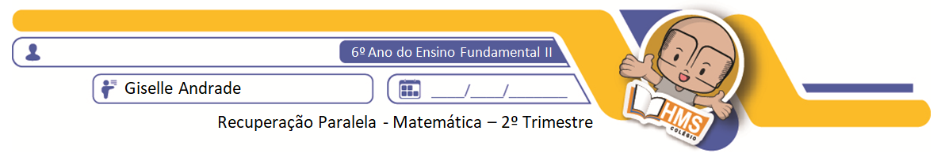

1) Transforme os números abaixo no sistema de numeração indo-arábico. Atenção, apresente todos os cálculos!

a) CCXIII ______________ e) MMMCDVII ________________

b) XXIX _______________ f) DCCCLXXXVIII _______________

c) CMLVI _____________ g) LXX _______________________

d) XLIV _______________ h) CXC ______________________

2) Agora, transforme os números indo-arábicos em números romanos.

a) 1952 ______________________ e) 2.406 ________________________

b) 44 ________________________ f) 93 ___________________________

c) 689 _______________________ g) 7.000 ________________________

d) 19 ________________________ h) 78 __________________________

3) Calcule as potenciações.

ex.: 2³ = 2.2.2 = 8

a) 5² = ___________________ e) ${10}^{4}$ = ___________________

b) 4³ = ___________________ f) = ____________________

c) = ___________________ g) = ___________________

d) = ___________________ h) = ____________________

4) Encontre a raiz das radiciações.

ex.: $\sqrt[2]{36}$ = 6 , pois 6² = 6.6 = 36

a) $\sqrt[2]{49}$ = _____________________ e) $\sqrt[6]{64}$ = ____________________

b) = _____________________ f) = ___________________

c) = _____________________ g) = ____________________

d) = ___________________ h) = _____________________

5) Calcule as expressões numéricas.

a) [ 100 : (4 . 8 – 27) ] : (6 . 7 – 38) = b) 7 . 2³ - 2² . 5 = c) . ( - 2³) =

6) Efetue as operações abaixo.

 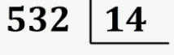 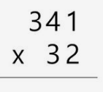 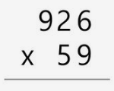

7) Identifique os sólidos geométricos.

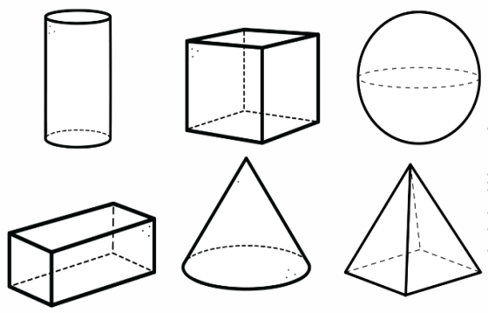

­­­­**____________________ ____________________ __________________**

**____________________ ____________________ __________________**

8) Dê o nome dos polígonos.

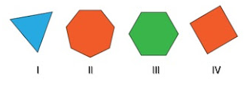

**I -________________________**

**II - _______________________**

**III - _______________________**

**IV - _______________________**