HMS – 3º ano – Exercícios do blog

- Read the text below and answer question 1, 2 and 3.

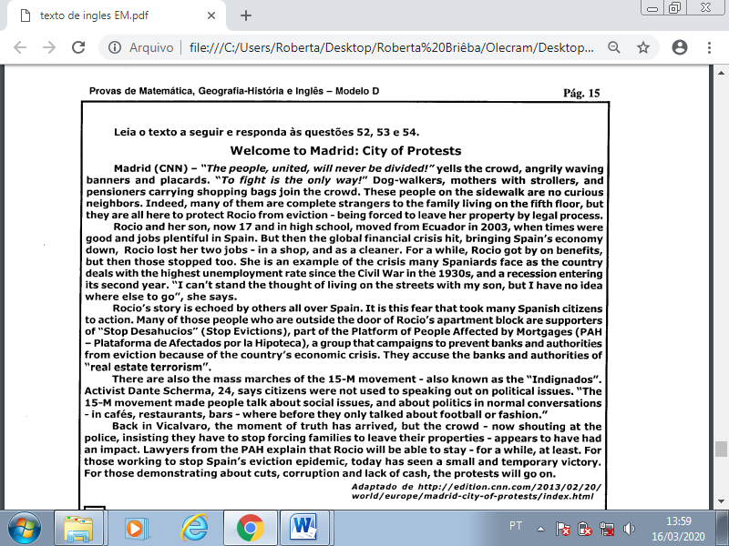

1. According to the text, Roccio:

a) moved to Spain when there were many jobs there.

b) was the only person affected by the crisis in Spain.

c) is getting benefits from Spain’s government nowadays.

d) had two jobs in Ecuador before moving to Spain.

e) has the best job in Spain nowadays.

2. According to the text, the 15-M movement made:

a) Spaniard’s lives lose their importance.

b) citizens in Spain more interested in social issues.

c) Spaniards talk more about football and fashion.

d) people go to cafés, restaurants and bars.

e) Spaniards accept evictions.

3. In the sentence “… insisting **they** have to stop forcing families to leave **their** properties…” the words **they** and **their** respectively refer to:

a) the crowd and families.

b) the crowd and the police.

c) the police and families.

d) the families and the properties.

e) the police and the properties.

4. Write 1st Conditional sentences, put the verbs in brackets in correct form:

a) If you _________________ (not study), you _____________ (fail) the test.

b) I _____________ (lend) you my umbrella if you _____________ (need) it.

c) If I ________________ (be late), I _______________ (call) you.

d) If Jane _________ (eat) too much chocolate, she __________________ (get) sick.

5. Write 2nd Conditional sentences, put the verbs in brackets in correct form:

a) If you _______________ (leave) your job, you ________________ (travel) around the world.

b) If you _____________ (be) nicer to him, he ____________________(lend) you the money

c) It _________________(be) nice if the rain ____________________(stop)!

d) If I _____________ (break) the mirror, I _______________ (be) in panic.

6. Complete the sentences with 3rd conditionals:

a) I _________ him the truth if I __________ it (tell/ know)

b) If he ______________ her before, he might _______________her to marry him. (meet/ ask)

c) He _______________ the message if he _______________ early. (receive/ leave)

d) They ___________ the question if they ______________ it. (answer/ understand)

e) I _____________ you the money if you _____________ me. (lend/ ask)

7. What´s the difference between 2nd and 3rd conditional? Explain and give an example.

_____________________________________________________________________________________________________________________________________________________________________________________________

8. Use the correct conditional structures to complete the sentences above:

a) If the weather is good, I ____________________. (go to the sports center)

b) If he hadn’t written, she ____________________. (be worried)

c) If they were rich, they ______________________. (study at a private study)

d) If you work hard, you _______________________. (get a promoted)

e) If she arrives early, I _______________________. (offer her a coffee)

- Read the text and answer question 9:

Join Anthony Melchiorri, host of Hotel Impossible, as he gives you his list of the top 04 things not to do when checking in to a hotel. From treating the staff correctly to keeping your cool, you'll be sure to have an even more enjoyable escape by using his extensive checklist.

1. Don't yell at the staff. Ever.

2. Don’t tell anyone your room number. (A desk agent should point to your room number, and not announce it to the world.)

3. Don't get bent out of shape when the night desk agent asks to see your “new friend’s” identification. Additionally, do not let a hotel employee into your room if they do not have an I.D.

4. Don't blame hotel staff for stealing your stuff. My personal experience is that the guests eventually find 99% of the items that guests report stolen from their rooms. However, it is your right to ask the manager to call the police to file a police report.

9. O que Anthony Melchiorri afirma a respeito de objetos furtados dos quartos dos hóspedes?

__________________________________________________________________________________________________________________________________________________________

- Read the text and answer question 10 and 11:

NEW YORK — It wasn’t too long ago that America had a love affair with soda. Now, an old flame has the country’s heart.

As New York City’s ban on the sale of large cups of soda and other sugary drinks at some businesses started on Tuesday, one thing is clear: soda’s run as the nation’s beverage of choice has fizzled.

In its place? A favorite for much of history: Plain old H2O. For more than two decades, soda was the No. 1 drink in the U.S. with consumption peaking in 1998 at 54 gallons a year, according to Beverage Digest. Americans drank just 42 gallons a year of water at the time.

But over the years, as soda increasingly came under fire for fueling the nation’s rising obesity rates, water quietly rose to knock it off the top spot.

10. O que contribuiu para o aumento do consumo de água nos Estados Unidos?

__________________________________________________________________________________________________________________________________________________________

11. Que medidas foram adotadas em Nova York para coibir o consumo excessivo de refrigerantes?

__________________________________________________________________________________________________________________________________________________________

12. Finish these sentences: (personal answers)

a) If you drive very fast, ………………………………………………………………………...

b) Would you give me some money if ………………………………………………………….

c) If she were my sister, ………………………………………………………………………...

13. I could have heard the telephone if I ……………………….. so deeply.

a) didn’t sleep b) hadn’t been sleeping

c) wouldn’t sleep d) wouldn’t have slept

14. You would have some money in your pocket if you ……………………. it so generously.

a) hadn’t spent b) didn’t spend c) couldn’t spend d) don’t spend

15. We wouldn’t be here now if we ……………………….. in that airplane crash.

a) were b) had been c) are d) had to be