1º ano – Bateria de exercício – 2º trimestre

Entregar até 04/08.

1. Complete the following sentences with the correct comparative form of the words listed below.

|  |
| --- |
| Bad – important - crowded - good - high - heavy - convenient – difficult - cheap - expensive - quiet - easy - thin – healthy - dangerous - ~~cold~~ |

1. In Canada, January is ___________colder______________ than March.

2. I think that good health is ________________________ than money.

3. I can’t carry my suitcase. It’s much ____________________ than yours.

4. I can afford to buy a new bike but not a new car. A car is _______________ than a bike.

5. You look _______________________ than the last time I saw you. Have you lost weight?

6. I couldn’t get a seat in the restaurant. It was _________________________ than usual.

7. Mountains are ________________________ than hills.

8. He got a very good mark on his exam. The exam was __________________ than he had expected.

9. You should go to the doctor. Your cold is _______________________ than it was a few days ago.

10. There is a lot of crime in the big cities. They are __________ than the small town where I live.

15. The store is having a great sale today. Most televisions are 25% _______________ than they were yesterday.

2. Read the text. Find five relative pronouns and write them down.

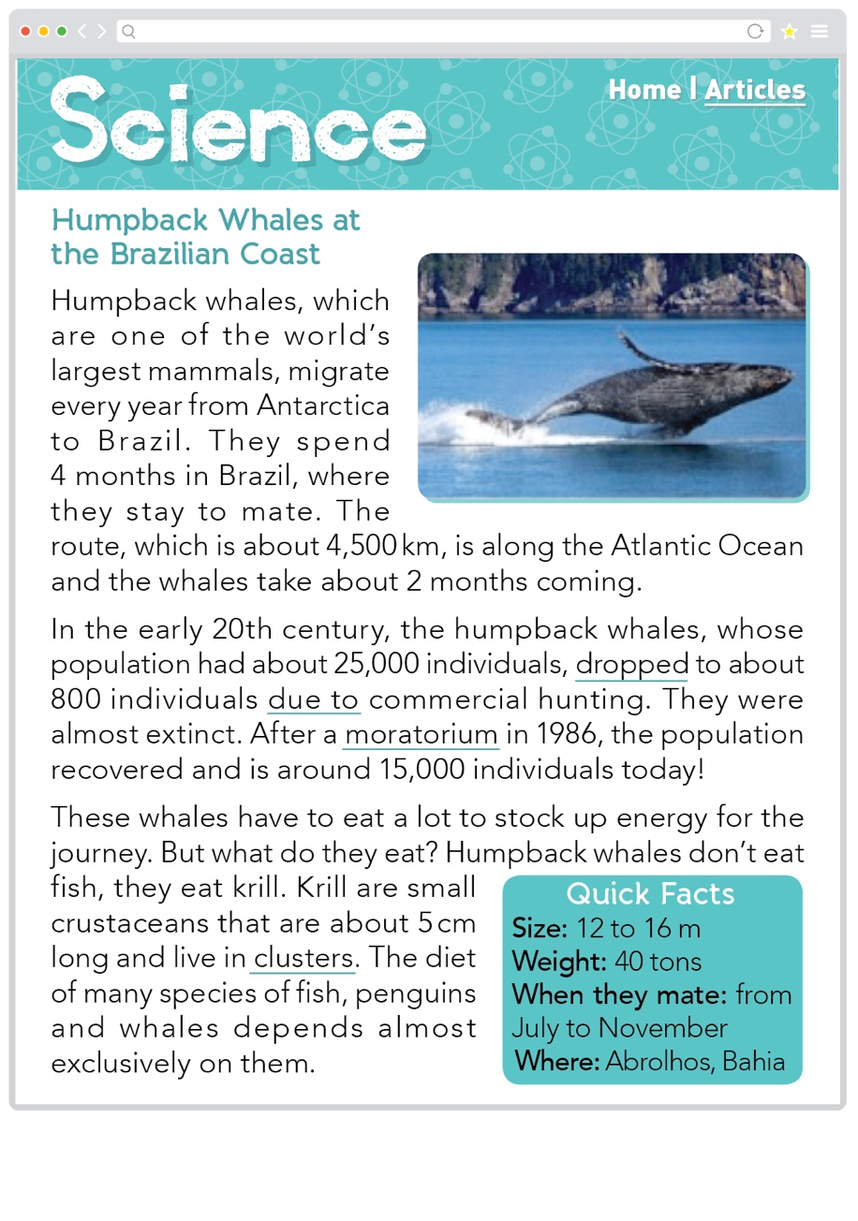

**Clue**

**humpback whale:** baleia-jubarte

**hunting:** caça

**to mate:** acasalar

**to spend:** passar

Based on <https://www.batepapocomnetuno.com/post/a-tour-through-the-ocean-understanding-the-comings-and-goings-of-humpback-whales>. Accessed on July 28, 2020.

a ____________________

b ____________________

c ____________________

d ____________________

e ____________________

3. Read the text in activity 1 again and write Y (yes) or N (no).

a ( ) The text presents facts.

b ( ) Whales are a type of crustacean.

c ( ) Humpback whales were extinct in the past.

d ( ) Humpback whales migrate all around the world.

e ( ) They swim in the Atlantic Ocean.

4. When can we see humpback whales at the Brazilian coast?

_______________________________________________________________

5. What do humpback whales eat?

_______________________________________________________________

6. Match the columns.

a This is the park… ( ) who is going to fix our car.

b I loved the book… ( ) where we can relax.

c That is the little girl… ( ) that you gave me.

d We called the mechanic… ( ) whose mother is a pilot.

7. Complete the following sentences with Present Simple: *(*don’t/doesn’t)*

* 1. My sister ___________ (not/ play) tennis every day.
  2. I ___________ (study) English at school from Monday to Friday.
  3. Chimpanzees ___________ (not/ speak) any language.
  4. She always ___________ (wear) skirts.

8. Complete the following sentences with Present Continuous:

* 1. What ___________ you ___________ (eat)?
  2. Kat ________________ (open) the window because she’s hot.
  3. My dog ________________ (not/ sleep) now.
  4. The girls________________ (listen) to music now.

9. Complete the following sentences with Present Simple or Present Continuous:

* 1. I ________________ (not/ study) French now.
  2. We always ________________ (play) cards during break time.
  3. Where __________ your granny ___________ (live)?
  4. Peter ________________ (not/ take) the children to school in the morning.
  5. What ________ your brother _________ (do) every morning?
  6. You ________________ (talk) a lot!!!

10. Use the words / phrases from the list to complete the sentences, as in the example:

* sell her car * be late for school * make a cake

* fix * lose weight

1. Jane’s putting an ad in the newspaper.

She *is going to sell his car.* …………………………………………………

1. The washing machine isn’t working.

My father …………………………………………………………………….

1. I bought some flour and some eggs.

I ………………………………………………………………………………

1. Robert is on a diet.

He ……………………………………………………………………………

1. Peter is still in bed.

He …………………………………………………………………………..

11. Jonathan is not satisfied with his life as it is. He has already decided to change a number of things. Look at the prompts and say what he intends to do, as in the example:

1. move to the city center

*He is going to move to the city center*………………………………………….

1. sell his car

…………………………………………………………………………………..

1. buy a bigger house

…………………………………………………………………………………..

1. marry Susan

………………………………………………………………………………….

5. apply for a job with a law firm

…………………………………………………………………………………..

12. Complete each sentence. Use GOING TO and the verb in brackets:

1. ………………. *Are you going to buy* ………………. (you / buy) a new bike?
2. Tom ………………………………………………………… (not / be) a doctor.
3. I ………………………………………………………... (buy) some new shoes.
4. ……………………………………………………….. (Helen / catch) the train?
5. Who ……………………………………………… (carry) the shopping for me?
6. Jim and Dinah …………………………………………… (not / get) married.

13. Rewrite each sentence or question with GOING TO:

1. Joe plans to buy a new computer next year.

… *Joe is going to buy a new computer next year.* …………………………..

1. We don’t plan to play tennis this weekend.

……………………………………………………………………………………

1. Does Nick plan to join the sports club?

……………………………………………………………………………………

1. What are your plans for next summer?

……………………………………………………………………………………

1. Look! That tree is about to fall over!

…………………………………………………..………………………………………