2º ano – bateria de exercício – 2º trimestre

Entregar até 04/08.

1) Fill in the correct RELATIVE PRONOUN:

1. Did you see the man …… *WHO* …… stole her bag?
2. The eggs ………………. you’ve bought are bad.
3. Please give me the keys …………………. are on the table.
4. Is that man ………………….. we saw in the park yesterday?
5. What’s the name of the lady …………………….. babysits for you?
6. Tom is playing with the dog ……………………. lives next door.
7. Have you eaten all the cakes ……………………. I made yesterday?
8. How old is the man ……………………. owns this shop?
9. Let’s all look at the picture …………………… is on page 7.
10. Has Peter returned the money …………………… he borrowed from you?

Read the article and answer questions 2 to 5.

Blood Type and Personality

Everybody knows their blood type , don’t they? No? Well, they do in Japan! Matching personality to blood type is very popular there. It all started in 1927 with studies of blood types and certain personalities by Furukawa Takeji, a Japanese psychologist.

People who believe in blood type theory think that people with blood type A are shy, artistic, and honest. They’re also hardworking and organized.

Type O people are outgoing and popular, but they don’t always finish what they start. They can be athletic, too.

Type B people are creative, independent, and have strong personalities. They’re often animal lovers. And people who have type AB blood can be outgoing and popular, but they can also be cold and shy. They also care about others.

According to this theory, people who have blood type A get along best with other type A people or type AB people. Type B people do better with people who are type B or AB. Type O people are more compatible with type O or AB. And type AB people can get along with everyone! Learning about blood type theory isn’t very Scientific . But it’s a lot of fun, isn’t it?

2) Do the Japanese enjoy matching personality and blood types?

______________________________________________________________________

3) Was Furukawa Takeji the first person to study personality and blood types?

______________________________________________________________________

4) Do Type O people always finish what they start?

______________________________________________________________________

5) Are Type O people most compatible with type O or type AB people?

______________________________________________________________________

Read and answer question 6 to 8.

What is the 17th letter of the alphabet? Are you singing the alphabet song to find the answer? It’s “Q”. Have you ever wondered why you can recite all the lyrics to an Adele or Cold Play song but can’t remember the equation for the circumference of a circle or the Spanish word for printer? When listening to music, following the lyrics and melody/rhythm requires both sides of our brains to be active, making it easier to remember information that’s simply read. That’s why you often have lines from songs stuck in your head, but you don’t find the same thing with passages from books.

Learning a new language? You should start by listening to a song; you will get a better sense of words and pronunciation. In addition to all these fabulous benefits, music is excellent to help you remember and recall information. Add to that increased motivation and improved mood, and you have a winning language learning tactic. When using music to learn, you can use your listening, speaking and (if you follow along with the lyrics) your reading skills.

(Adaptado de: T-SKEET, J. Why Learning a Language from Music is Easier. Voxy)

6) Segundo a autora, é mais fácil memorizar músicas que outros tipos de informações. Explique, de acordo com o texto, por que isso acontece.

__________________________________________________________________________________________________________________________________________________________________________________________________________________

7) Cite três benefícios da música para o aprendizado de línguas estrangeiras mencionados no texto.

__________________________________________________________________________________________________________________________________________________________________________________________________________________

8) Qual é a resposta para a primeira pergunta do texto que o texto faz?

______________________________________________________________________

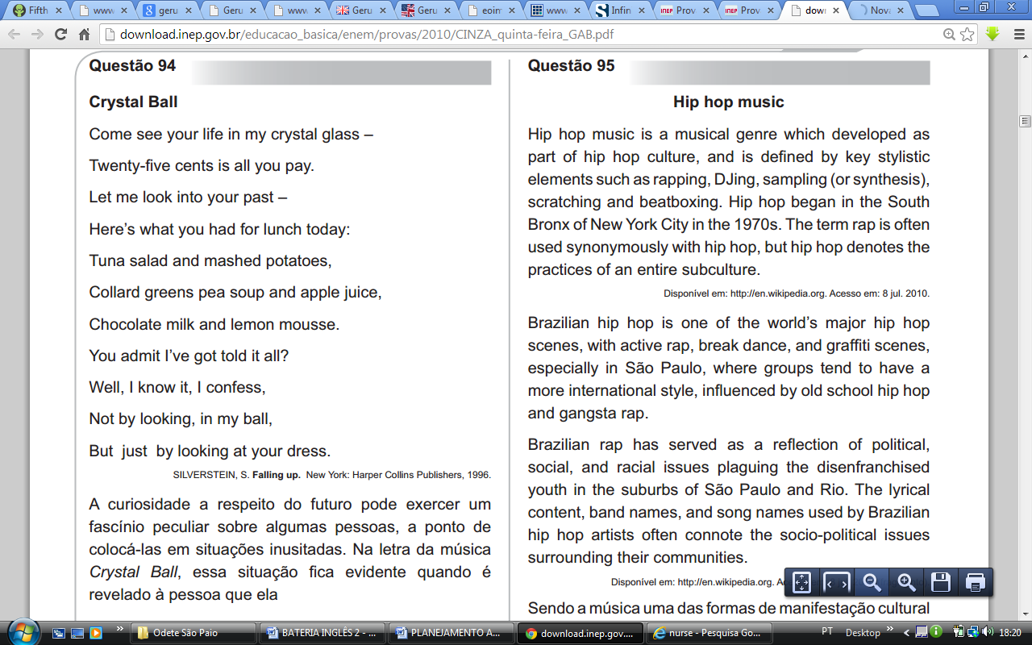Texto para a questão 9 a 11.

9) Qual é o assunto principal do texto?

___________________________________________________________________________________________________________________________________________

10) Sendo a música uma das formas de manifestação cultural de um país, como tem sido caracterizado o rap brasileiro, a partir das informações do texto?

___________________________________________________________________________________________________________________________________________

11) Onde e quando se iniciou o movimento Hip Hop?

____________________________________________________________________________________________________________________________________________

12) Por que São Paulo é o Estado brasileiro mais influenciado pelo Hip Hop?

____________________________________________________________________________________________________________________________________________

13) Qual é o tema exposto nas letras do hip-hop?

____________________________________________________________________________________________________________________________________________