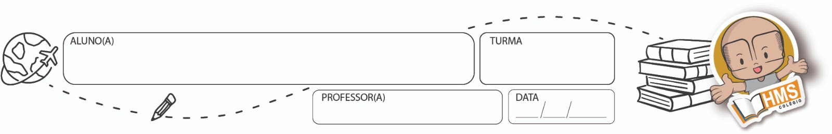

RECUPERAÇÃO PARALELA – FÍSICA – 2º TRIMESTRE

1) Explique a diferença entre ondas mecânicas e ondas eletromagnéticas. Destaque a necessidade de meio material para propagação e dê exemplos de cada tipo.

_________________________________________________________________________________________________

_________________________________________________________________________________________________

_________________________________________________________________________________________________

_________________________________________________________________________________________________

_________________________________________________________________________________________________

2) Descreva como se forma uma onda mecânica em uma corda. Descreva o papel da vibração da fonte, o meio de propagação e o tipo de onda gerada.

_________________________________________________________________________________________________

_________________________________________________________________________________________________

_________________________________________________________________________________________________

_________________________________________________________________________________________________

_________________________________________________________________________________________________

3) **O que ocorre com a velocidade de uma onda mecânica quando ela passa de um meio menos denso para um meio mais denso?** Explique a razão física dessa mudança e cite um exemplo cotidiano.

_________________________________________________________________________________________________

_________________________________________________________________________________________________

_________________________________________________________________________________________________

_________________________________________________________________________________________________

_________________________________________________________________________________________________

4) **Em uma corda esticada, qual é a relação entre a frequência, o comprimento de onda e a velocidade de propagação de uma onda mecânica?**

**_________________________________________________________________________________________________**

**_________________________________________________________________________________________________**

**_________________________________________________________________________________________________**

**_________________________________________________________________________________________________**

**_________________________________________________________________________________________________**

5) **Compare as ondas longitudinais e transversais.** Escreva as principais características de cada tipo e forneça exemplos de onde podem ser encontradas na natureza ou em aplicações tecnológicas.

_________________________________________________________________________________________________

_________________________________________________________________________________________________

_________________________________________________________________________________________________

_________________________________________________________________________________________________

_________________________________________________________________________________________________