Recuperação paralela – 2º ano – entregar em mãos até 22/06.
Estudante: _______________________________________________________________________

1. Complete the sentences. Use the Present Perfect of the verbs in parentheses.
a) I’m afraid I ___________________________ my car keys. ( lose )
b) We ________________________ in Chicago many times. ( be )
c) She __________________________ my book at last. ( return )
d) He __________________________ us many times. ( visit )
e) It _________________________ a lot this year. ( rain )
f) She _____________________ tennis with Anna yet. ( not play )
g) _________________ he ________________ his History Exam yet? ( do )
h) She ____________________ lunch with Sam yet. ( have )

2) MARK the correct alternative.

a) ( ) He hasn’t traveled to The USA.
( ) He hasn’t travel to The USA.

b) ( ) She has already eaten Chinese food.
( ) She has already ate Chinese food.

c) ( ) I have already fall down on a sidewalk.
( ) I have already fallen down on a sidewalk.

d) ( ) Have you already eat roast beef?
( ) Have you already eaten roast beef?

e) ( ) He have just arrived.
( ) He has just arrived.

3) Complete the sentences. Use the words below.
yet – haven’t – ever – have – already

a) I _________________ never ridden a motorbike.
b) Have you _______________ seen a ghost?
c) Marco has _____________ sent an e-mail this minute.
d) Nina hasn’t done her homework ________________.
e) They _________________ had dinner yet.

4) Choose the correct answer.

a) Have you visited your favorite college ___________? ( yet - ever )
b) I have ______________ cheated on a test. ( never - yet )
c) I’ve ________________ been to college. ( yet - already )
d) _____________ she ever fallen in love? ( Have - Has )
e) I haven’t studied Japanese _____________. ( yet - just )

5) Complete the sentences using the Past Perfect.

a) She (not / ride) _______________ a horse before that day.
b) My brother ate all of the cake that our mum (make). _____________________
c) When she went out to play, she (do) _________________her homework.
d) He (not / be) _______________ to Cape Town before 1997.
e) I could not remember the poem we (learn) _____________________the week before.
f) The waiter brought a drink that I (not / order) ____________________.

6) Underline the correct answer.
a) I got home and found that someone (had tried – tried) to break into the house.
b) I celebrated last Friday night because I (passed – had passed) my exams the day
before.
c) I saw a bad accident on my way here. Two cars (had crashed – crashed) on the
crossroads.
d) I got to the cinema and a minute later the film (had started – started)
e) I (gone – went) to Ireland in 2008 and to Norway in 2009.
f) When I married Helena in 2007, I (had been – were) married three times before.
h) I got to the cinema and saw that the film (had already started – started).

- Texto para as questões 7,8 e 9.
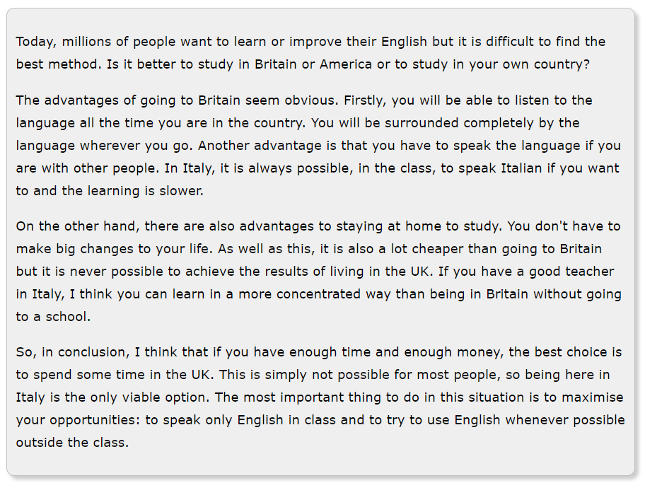
7. Qual é uma das vantagens de permanecer em seu país de origem para aprender inglês?
________________________________________________________________________________________________________________________________________________________________________________________________
8. Qual é uma das desvantagens de permanecer em seu país de origem para aprender inglês?
________________________________________________________________________________________________________________________________________________________________________________________________
9. O que podemos concluir, segundo o texto?
________________________________________________________________________________________________________________________________________________________________________________________________

