Recuperação paralela – 3º ano – entregar em mãos até 22/06.
Estudante: _______________________________________________________________________

1. Transform the following sentences from direct speech into reported speech:
a) “I am always in a bad mood on Monday mornings,” said Brian.
_______________________________________________________________________
b) “They were working last week,” she said.
_______________________________________________________________________
c) “I have been to Zimbabwe,” said Evelyn.
_______________________________________________________________________
d) “Isabell will give you a lift to the airport tomorrow,” he said.
_______________________________________________________________________
e) “We had already eaten before we arrived so we didn’t taste the food,” said Simon.
_______________________________________________________________________

2. Transform the following sentences from reported speech into direct speech. Pay attention to the punctuation required when using direct speech.
a) She said that they had paid the bill.
_______________________________________________________________________
b) Kelly said she was so tired of working every weekend.
_______________________________________________________________________
c) He said their house had been for sale for six months.
_______________________________________________________________________
d) Mark said that he had gone surfing the weekend before.
_______________________________________________________________________
e) Max said he could help us move flats tomorrow.
_______________________________________________________________________

3. Connect the first sentences with the second one. Pay attention to conditional structures.
1.Helen wouldn’t have missed her train ( ) his job would be easier.
2. If I were you, ( ) if we walk faster.
3. Patrick would retire ( ) I would accept their offer.
4. If Brian had a secretary, ( ) if she had woken up earlier.
5. You’ll soon feel better ( ) she would have bought a car.
6. If it rains, ( ) if you take some aspirin.
7. If Tracy had passed her driving test, ( ) we won’t have the barbeque.
8. I would watch TV more often ( ) if the programmes were better.
9. If you followed a language course in Spain, ( ) your Spanish would improve.
10. We’ll catch the bus ( ) if he had enough money.

4. Underline the correct alternative.
a) If you are / were hungry, I’ll make a sandwich.
b) You would get / would have got the job if you had worn something different.
c) If I had been / were rich, I would buy a big house in the city center.
d) We would invite / would have invited Peter if we had known he was in town.
e) If Jason didn’t drive / hadn’t driven me to the airport I would have missed my plane.

5. Use FIRST, SECOND or THIRD conditional to complete the sentences below.
a) If I am not busy, I ________________ (drive) you to the station.
b) I ________________ (buy) those trainers if they hadn’t been so expensive.
c) If Charles ________________ (not lie) all the time, I would believe him.
d) Michael will get good results if he ________________ (study) hard.
e) If Mark weren’t selfish, he ________________ (have) a lot of friends.
f) Nick ________________ (lose) his job if he arrives late at work every day.
g) We wouldn’t have missed our train if the traffic ________________ (not be) so bad.

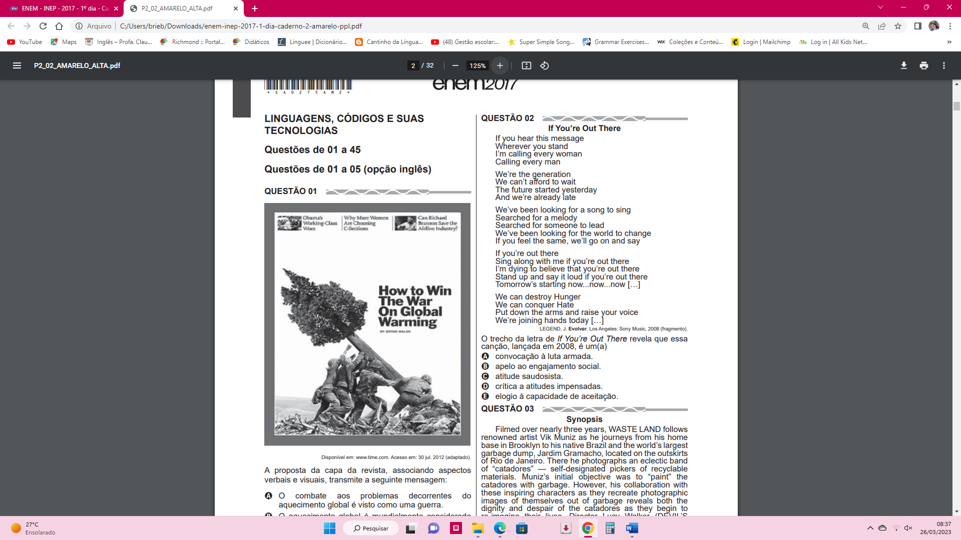
6. A proposta da capa da revista abaixo, associando aspectos verbais e visuais, transmite que mensagem?
____________________________________________________
____________________________________________________
____________________________________________________
_____________________________________________________
_____________________________________________________
_____________________________________________________
_____________________________________________________

