

2ª BATERIA DE EXERCÍCIOS – MATEMÁTICA – 9° ANO

1) Complete as equivalências da radiciação com as potenciações.

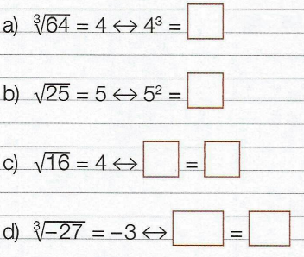 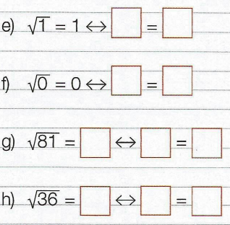

2) De acordo com o exemplo, divida o índice e o expoente para os radicais: 

a) = _______________________ d) = ______________________

b) = ______________________ e) = ______________________

c) = ______________________ f) = _______________________

3) Calcule a raiz enésima de um produto: 

a) = __________________ b) = ______________________ c) = ____________________

4) Calcule a raiz enésima de um quociente: 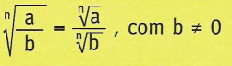

a) = __________ b) = _________ c) = _________ d) = _________

5) Simplifique os radicais.

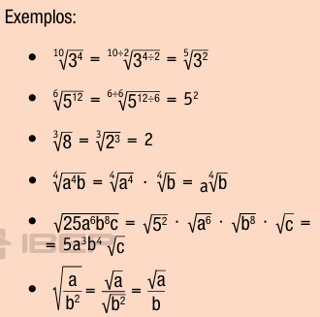

= _________________________

= _______________________

= _________________________

= _________________________

= _________________________

= _________________________

= _______________________

= ________________________

= _______________________

= _______________________

= _______________________

6) Insira um fator em um radical. Desenvolva as multiplicações, colocando os fatores nos radicais.

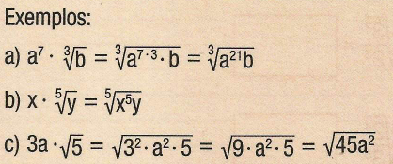

a) $x^{3}$. $\sqrt[5]{y}$ = ___________________________________

b) $a .\sqrt[7]{b}$ = ____________________________________

c) $m .\sqrt{a}$ = ____________________________________

d) = ____________________________________

e) = _____________________________________

f) = ____________________________________

g) 2x = ___________________________________

7) Adição e subtração com radicais semelhantes. Resolva as operações.

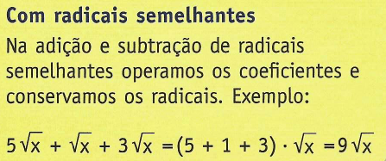

|  |  |  |
| --- | --- | --- |
| = | = | = |
| = | = | = |

8) Adição e subtração com radicais não semelhantes. Simplifique e reduza os termos.

|  |  |  |
| --- | --- | --- |
| a) + = | b) + + = | c) + + = |

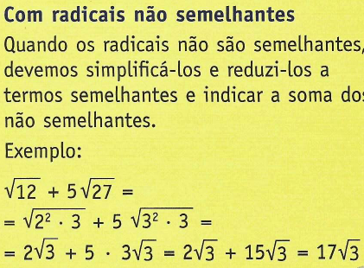

9) Multiplicação e divisão de radicais. Efetue as operações.

a) $\sqrt{3}$. $\sqrt{2}$ = ______________________________________

b) $\sqrt{2}$. $\sqrt{3}$. $\sqrt{5}$ = _________________________________

c) $\sqrt[3]{5}$. $\sqrt[3]{2}$ = _____________________________________

d) $3\sqrt{2}$. $5\sqrt{3}$ = __________________________________

e) $\sqrt{3}0$: $\sqrt{6}$ = ___________________________________

f) $6\sqrt[3]{10}$: $3\sqrt[3]{5}$ = _________________________________

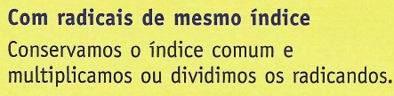

10)

a) . = ________________________________________

b) . = _______________________________________

c) . = _______________________________________

d) . = ______________________________________

e) . = _______________________________________

f) : = ________________________________________

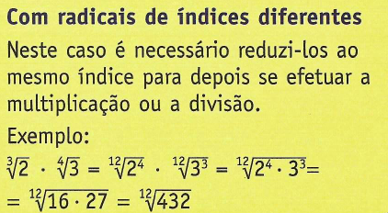

11) Uma caixa possui as seguintes dimensões:

V = comprimento (cm) x largura (cm) x altura (cm) = cm³

Calcule o **volume** das figuras abaixo.

